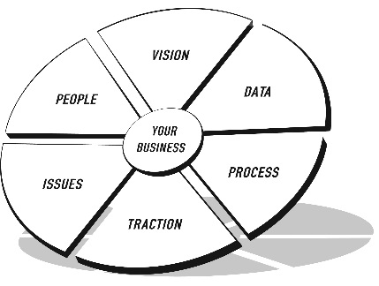
THE EOS MODEL™
THE VISION/TRACTION ORGANIZER™

ORGANIZATION NAME:

VISION

CORE VALUES |  | 3-YEAR PICTURE™
Future Date:
Revenue:
Profit:
GPM:
Number and Quality of People:

Added Resources:

Office Environment and Size:

Operational Efficiencies:

Product Mix:

Customer Mix:

CORE FOCUS™ | Purpose/Cause/Passion (Vision):  Our Niche (Mission):
10-YEAR TARGET™
MARKETING  STRATEGY | Target Market/“The List”:  Three Uniques:  Proven Process:  Guarantee:
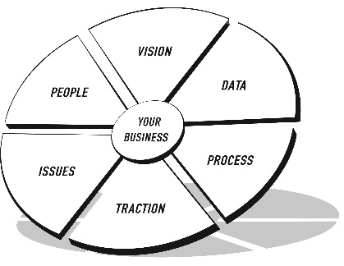
THE EOS MODEL™
THE VISION/TRACTION ORGANIZER™

ORGANIZATION NAME:
TRACTION
1-YEAR PLAN | ROCKS | ISSUES LIST
Future Date:  Revenue:  Profitability:  GPM:  Measurables:  Goals for the Year:  1.  2.  3.  4.  5.  6.  7.  With your cursor in the last row, press Tab to add another row. | Rocks for the Quarter: Who  1.  2.  3.  4.  5.  6.  7.  With your cursor in the last row, press Tab to add another row. | 1.  2.  3.  4.  5.  6.  7.  8.  9.  10.  11.  12  13  14.  With your cursor in the last row, press Tab to add another row.

